MODULE- 2

Understanding Harmony in the Human Being - Harmony in Myself!

Introduction:

Human being a combined unit of body and soul and so it is natural that there must be a perfect harmony between these two, to live a happy and peaceful life .There is the familiar shape and structure of a human being that is immediately apparent to us and we imagine someone with similar human body-like features. But in addition to the body, there is also the aliveness of the person – the entity that keeps the body ‘alive’ and makes it operate in various ways.
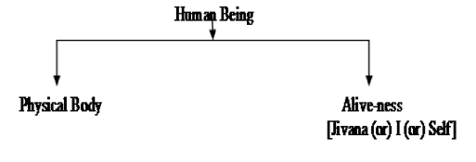
We perceive this aliveness in the activities demonstrated by the person like their seeing, talking, listening, walking, and eating, etc. This aliveness is called Jivana. Thus, a human being is coexistence of the body and jivan. This jivan refers to itself as ‘I’ (self). Thus we say “I am so and so” or “I feel tired” or “I am happy” and not “my body is happy”. This I or self is also called ‘consciousness’ and is the sentient constitute of the human being.

Understanding human being as a co-existence of the sentient ‘I’ and the material ‘Body’
‘Human being is the co-existence of the Self (I) and the Body’: The human being is the co-existence of ‘I’ and the body, and there is exchange of information between the two, i.e. ‘I’ and body exist together and are related. There is a flow of information from ‘I’ to the body and from body to the ‘I’. We can make this distinction between the self and the body in two ways in terms of the needs, activities and the types of these two entities. All the needs of I, say respect, trust, etc., can be called as Happiness (sukha), while the needs of body are physical facilities (suvidha) like food. The two things are qualitatively different. There is no relevance of quantity for the needs of I as it is qualitative, while the needs of body are quantitative, and they are limited in quantity.
The activities of ‘I’ are activities like, desire, thinking, selection, while the activities of body are activities like eating, breathing etc. The mode of interaction of ‘I’ includes knowing, assuming, recognizing and fulfilment. The fulfilment depends on recognition depends on assumptions and assumptions depends on knowing or not knowing (beliefs). If assuming is based on knowledge, then recognition will be correct and fulfilment will be correct. If assuming is not based on knowledge, then things may go wrong. The mode of interaction of body is only recognizing and fulfilling. Self is a conscious entity and the body is a material entity, or physic-chemical in nature. Thus we can say:
To conclude we can say that the human being can be understood in terms of a co-existence of two entirely distinct entities, namely sentient ‘I’ and material body. Their needs and activities are quite different and have to be understood accordingly. But these two constituents of human being are to act in close synergy with each other.
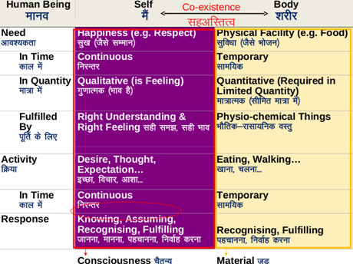
Understanding the needs of Self (‘I’) and ‘Body-’happiness and physical facility
Needs of body are physical facilities. Physical facilities are needed for the body in a limited quantity. When we try and exceed these limits, it becomes troublesome for us after some time. Let’s take the example of eating. As far as, physical facilities (say rasgulla) go, they are necessary in the beginning, but if we keep consuming, it becomes intolerable with the passage of time. This applies to every physical facility. We can only think of having unlimited physical facilities, but if we try and consume, or have too much of physical facilities, it only ends up becoming a problem for us. When we try to perpetuate physical facilities, the following pattern results. With time it successively changes from:
Necessary and tasteful
↓
Unnecessary but tasty
↓
Unnecessary and tasteless
↓
Intolerable!

Distinguish between the needs of self and the needs of body.

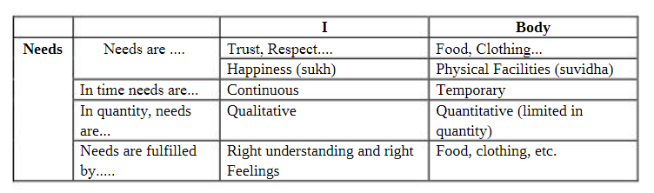
1.Needs are ....The needs of the body like food for nourishment clothes for protection, and instruments to ensure right utilization can be categorized as being 'physical' in nature, or also called 'physical facilities' (suvidha) whereas the need of I is essentially to live in a state of continuous happiness (sukh). The needs of the body are physical in nature, whereas the needs of the self ('I') are not physical in nature -like trust, respect, happiness etc.

2.In time, needs are...The needs of 'I' are continuous in time, unlike the need of the body, which is temporary in time. We want happiness continuously. We also want the feeling of respect continuously and so also acceptance in relationship. If we talk about food, clothing, shelter, or instruments, these are needed only for some amount of time, or we can say that the need for physical facilities of the body is temporary in time- it is not continuous.

3.In quality, needs are.....Physical facilities are needed for the body in a limited quantity. When we try and exceed these limits, it becomes troublesome for us after some time. Let's take the example of eating. As far as, physical facilities (say rasgulla) go, they are necessary in the beginning, but if we keep consuming, it becomes intolerable with the passage of time. This applies to every physical facility. We can only think of having unlimited physical facilities, but if we try and consume, or have too much of physical facilities, it only ends up becoming a problem for us.
Whereas the needs of 'I' are qualitative (they are not quantifiable), but we also want them continuously. Our feelings are qualitative. Either they are or they are not. Ex. Happiness is qualitative. Either we are feeling happy or we are not. Also if a feeling is not naturally acceptable; we do not want it even for a single moment. If acceptable, we want it continuously.

4.Needs are fulfilled by....The need of the self ('I'), for happiness (sukh) is ensured by right understanding and right feelings, while the need of the body, for physical facilities (suvidha), is ensured by appropriate physico-chemical things.

Understanding the characteristics and activities of ‘I’ and harmony in ‘I’
The self is conscious in nature while the body is physico-chemical in nature. The interaction between the ‘I’ and the body is in the form of exchange of information. So the focus of attention is on two categories of attributes of the self, namely, the powers of the self and the corresponding activities as the manifest outcomes of these powers.
1. Power: This means the basic capacity in the self (‘I’). They are: desires, thoughts and expectations.

2. Activities: The activities are: imaging, analyzing, and selecting/tasting. The activity of analyzing means breaking down the image into various parts or to open it up. Selecting/tasting is with the expectation of fulfilling our desires with the expectation of happiness. The activity of selecting/tasting is the basic level via which the self interacts with the body.
A simple example to understand these activities is a follow:

➢ We may have desire to have respect by being the owner of a big house. This is in the form of imaging – we have an image in us of fulfilment of this need for respect via a house.

➢ Based on this desire, we start working out the details of the house. Ex no. of rooms, storey’s, on which floor in will stay. The image of wanting respect from the house is split into many parts – this is called analyzing. The activity of analyzing means breaking down the image into various parts.

➢ Now that we have worked out the details of the house, we go about choosing the size, colour etc. of the room. This is called selecting / tasting.

Activities of Human-Beings:

If we look at the variety of activities that we are engaged in commonly – we see that we can put them in three categories:

1. Activities that are going on in the self
2. Activities involving both the self and the body
3. Activities that are going on in the body
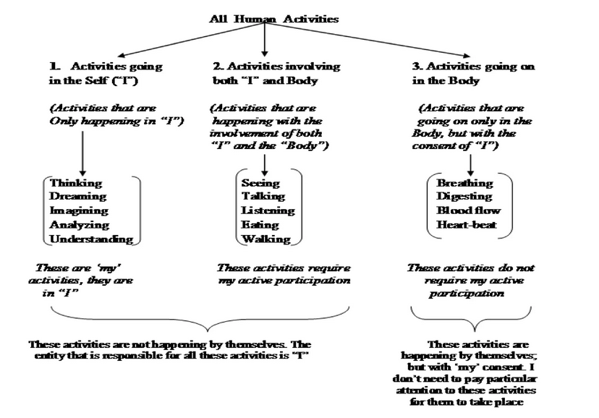

Knowing, assuming, recognizing and fulfilling are the activities involving both the self and the body.

1. Activities of recognizing and fulfilling in the body: Apart from the activities of Breathing, Heartbeat, Digestion etc., the activities of the body can also be understood as recognition and fulfilment. In fact, the mutual interaction between any two material entities can be understood as recognition and fulfilment of their relationship. For example when we are thirsty and drink water, the body absorbs the water to the extent needed and uses for the nourishment of the various organs. Here, body recognizes its relation with water and fulfils it.
Recognizing → Fulfilling
2. Activities of knowing, assuming, recognizing and fulfilling in the self (‘I’): When it comes to self (jivan or ‘I’), which is a conscious entity; in addition to ‘recognizing and fulfilling’, there is also the activity of assuming and that of knowing. In fact, recognizing and fulfilling in case of human beings will depend upon knowing and/or assuming.
a. We assume – We all make assumptions and our response (recognition and fulfilment) is dependent on the assumption. For ex.: If I see a snake and assumed it to be a rope, I shall respond differently to it, than if I take it to be a snake itself. We call this activity ‘assuming or mannana’.
b. We recognize – We all recognize things today, we recognize a variety of things. Like, we recognize water, our parents, friends, etc. We call this activity ‘recognizing or pahachaanana’. The recognizing in ‘I’ depends on assuming.
c. We fulfil –The response that follows recognition is called the activity of ‘fulfilling or nirvaha karna’. The fulfilment depends on the recognition. For ex.: Once we recognize water, we take it. Taken together we can write it as (in I):
Assuming → Recognizing → Fulfilling
There is another activity that exists in us (in ‘I’). This activity is called ‘knowing’. Knowing means we have the right understanding – the understanding of harmony at all levels of our living. When we have the right understanding, when we have the knowledge of reality, it is definite, and then assuming becomes according to the knowing, and hence recognizing and fulfilling becomes definite, or according to knowing. Until then, it is subject to beliefs and assumptions, and this keeps changing. When we list these down:

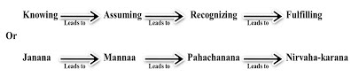
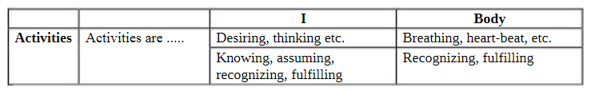

Understanding the Body as an instrument of ‘I’ (I being the doer, seer and enjoyer)

It has been stated earlier that body and “I” are two separate entities. It is “I” who has to take the decisions for the body to accordingly, e.g.., requirement of food. It is “I” who decides to eat and thus, passes the information to the body.
For example, the moment “I” Choose to take food. the body shall eat food. With decision to take food, the food shall be picked by. Chewed and then swallowed by the body Similarly, “I” decide to take rest to ensure adequate regaining of energy, then body shall go to bed and will take rest. Thus body is used as an instrument of “I”.

- I am the seer: We are involved in the activities of seeing and understanding when reading a book, watching T.V., thinking, or when someone is explaining us. When we see something nice like scenery, then we say “I am Seeing” this will mean that our self (I) is seeing through eyes. Eyes are just used as instruments.
When we are reading a book or listening, when someone is explaining something to us, when we are watching a scenery or when we are thinking – we are engaged in the activities of ‘seeing’ or understanding. Now when we see some nice scenery we say ‘I am seeing’ that means our self ‘I’ see via the eyes, the eyes don’t see, they are just instruments, that unable me to see something outside. Different images are formed in the eyes every time, but it is I who is able to relate it to the meaning of that image every time. Similarly, I can see inside ‘in me’ also – without the eyes. For example, I can see that I am getting angry. In this case I understand or know or am aware that I am getting angry. When I see outside the body works as an instrument.

- I am the doer: When we are performing certain action, we are similarly engaged in the activity of “doing” something. For example, I am dialling phone to friend. If somebody asks me “who is doing this and that”, THE ANSWER SHALL BE “I am doing”. In fact, “I” consciousness is doing through the instrument of body and performs certain functions like picking up the phone, seeing the number and then dialling. This “I” consciousness is the doer or karta.
Once I have seen/ understood something, I am the one who decides what to do or not to do. I am the doer. For example, when I see the scenery I am the one who decide to take a picture of the scenery. I use my hands to pick camera and click a picture. The hands in the body are thus used as an instrument. In this way I work with my hands and legs.

- I am the enjoyer: When I look the scenery and take picture. I am the one who sees and does so far. When I see the picture I like it and enjoy it. Thus, a flow is maintained of being seer, doer and enjoyer. In the same way when I eat, I get taste from the tongue.

Preconditioning & Sensation

Conflicts when our activities are not guided by our natural acceptance: When our activities are not guided by our natural acceptance, then they are guided by preconditioning and sensations.
Preconditioning means we have assumed something about our desires on the basis of prevailing notion about it. They comes from what we read, see hear, what our parents tell us, our friends talk about what the magazines talk of, what we see on the TV etc. We have not self-verified the desires in our own right. As a result, we are not clear about what we will get out of fulfilment of that desire. The problem with that is, unless we verify our desires, we may not even know whether they are our. We may end up spending an entire lifetime accumulating desires that are not ours, and in running about trying to fulfil them.
Sensation is a perception associated with stimulation of a sense organ or with a specific body condition: the sensation of heat; a visual sensation. We go into conflicts when our activities are not guided by our natural acceptance:

A. Conflicts and contradictions in ‘I’ as a result of pre-conditioned desire
We have not verified the desires, thoughts and expectations in us on the basis of our own natural acceptance. As a result, these desires, thoughts and selections are in conflicts. Since the desires are in conflict, the thoughts they give rise to, are also in conflict and in turn, the selection from the thoughts are also in conflicts. This conflict affects us in different manners:
1. Wavering aspirations: Our goals keep shifting as the inputs from the outside also keep changing. Our desires thus keep shifting, because their source is outside and these preconditioned desires may come from what we read, see, hear, from media, friends, society, etc. hence, we are always wavering in what we want; we are not able to be certain about it.
2. Lack of confidence: Since our desires are shaky, we are not sure about them. As a result, we lack self confidence, in the true sense. Our confidence seems relative i.e. we keep comparing ourselves with others in order to feel confident.
3. Unhappiness/conflicts: Since our desires, thoughts and expectations are in conflict, it becomes the cause for our unhappiness, leading to stress and tension. Such desires will also be in conflict with our natural acceptance
4. Lack of qualitative improvement in us: We focus largely on fulfilling the needs of the body. As a result, we live with a sense of lack of fulfilment. We are doing many things, accumulating a lot, progressing on paper, but we don’t feel that we have improved, that we have become better. It seems that only the things around us are changing!
5. State of resignation: Because we do not understand ourselves properly and have contradictions within, we slowly start getting disillusioned (pleasant but mistaken beliefs). We feel that there are no solutions to these issues, and end up in a state of resignation.

B. Short lived nature of pleasure from sensations: The pleasure obtained from sensations is short-lived. We have so much dependent on sensations that instead of giving us some sensory pleasure, it becomes the source for our happiness. This can be understood as follows:
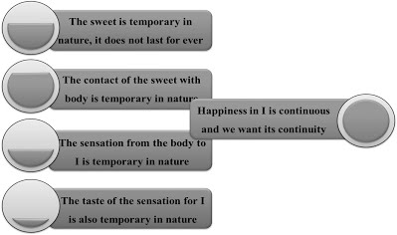

The external object is temporary in nature the contact of the external object with the body is temporary in nature. The sensation from the body to ‘I’ is temporary. And at last the taste of the sensation from the body in ‘I’ is also temporary. Therefore, if the source for our happiness is temporary by definition, then our need for continuous happiness will never be fulfilled. Hence, any sensation we have from the body can’t be the source for our lasting happiness.

To sum up, if our desires, thoughts and expectations are based on pre-conditionings, we are generally in a state of great confusion. This leads to confusion, unhappiness, conflict and stress. We have lack of clarity about the self, relationships, society, nature and existence. We have lack of confidence. We have a feeling of being unfulfilled, unsettled. We operate largely on the basis of the environment, driven from the outside – either from sensations, or based on pre-conditionings.

Present Scenario
Today, our thoughts and expectations are largely being set by pre-conditionings and sensations which are causing unhappiness, stress and discomfort in our lives. Such expectations can lead to contradictions in us as we cannot be sure of ourselves.
Scenario 1: Desires set on the basis of pre-conditioning:
Pre- conditioning means to assume something about anything on the basis of a prevailing notion without self-verification.
For e.x.: While seeing advertisements, we pay attention to it and start thinking about it and associate some greatness with it and slowly the thought becomes our desire. It is a preconditioned desire and we don’t know what we are going to get out of the fulfilment of this desire. Sometimes we are not even aware of the existence of such a desire in us.

Scenario 2: Expectations set on the basis of sensation:
Sensation is a feeling resulting from something that comes into contact with the body.
For e.x.: We may develop a desire for a bike based on the way it looked (sensation) or the taste associated with it.

Understanding the harmony of I with the Body: Sanyam and Swasthya

Introduction: Our present lifestyle and conditionings are not very conductive to keep the body fit and therefore it is important to understand sanyama and swasthya correctly and maintain proper harmony with the body.

Sanyama:Sanyama means the feeling of responsibility in the self (I) for nurturing, protection and right utilization of the body. Self-control or sanyama is the control of the mind and its desires, urges, emotions and delusions. It is controlling the outgoing tendencies of the mind and the senses and bringing them back to our self within.

Swasthya: Swasthya is the condition of the body where every part of the body is performing its expected function. The word swasthya literally means being anchored to the self, being in close harmony with the self. In other words, swasthya, in Sanskrit means self– dependence (swa = your own). Also, embedded in its meaning are health, sound state, comfort and satisfaction. So we can say that sanyam ensures swasthya.

Brining harmony between self and body by using Sanyama and Swasthya:

With right understanding, I get self-organized and take care of the body properly. With lack of right understanding, I am able to do it and the body becomes unhealthy. With right understanding and right feelings, the body gets favorably affected. For example; when I am happy, the temperature and pressure in the body are normal, when I am angry or tense, they get upset. It means if I am in disharmony, say in anger or stress or despair, it immediately starts affecting the body adversely. There are many diseases of the body that are caused due to disharmony in ‘I’. These are called psychosomatic disease, such as asthma, allergies, migraine, diabetes, hypertension etc. so we can say that sanyam has a strong effect on swasthya.
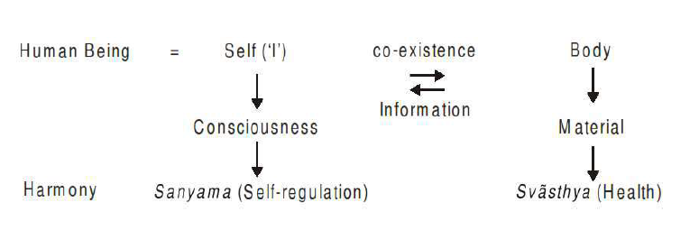

Programs to ensure Sanyam and Health

1. Understanding and Living with Sanyama:

Sanyama implies that the self takes the responsibility for proper nurturing, and right utilization of the body. For this it is essential to understand the functioning of the body instrument. It is also essential to understand that this instrument has a limited life span and undergoes a pattern of growth and decay. The interaction of the self with the body has to be in consonance with the above objectives which are achieved through sanyama.

2. Understanding the self organization of the body and ensure health of the body:

a. Nurturing of the Body: Proper Food, Air, Water, Etc.: In the process of selecting food for the body, I need to make out the elements which make a complete food so that it gives required nutrients and energy to the body. On the basis of understanding of the harmony of the self with the body, it can be said that the food needs to be eaten only when we feel hungry. The choice of the food has to be such that it is easily digestible and the food needs to be taken with proper posture of the body and in right quantity.
b. Protection of the Body: The second issue is the protection of the body. The clothes we choose for protection need to be such that they ensure proper interaction of the body with the environment. The right amount of exposure of the body to the air, water, and sun is required to ensure its proper functioning. To ensure the heath of the Body, we need to take care of the following- i) Ahar-Vihar, ii) Shram- Vyayam, iii) Asana-Pranayam and iv) Aushadhi-Chikitsa. We have already discussed about Ahar (Food), let us now discuss about the others:

- Proper upkeep (Vihar) of the Body: When we work, the Body gets tired. When we take rest, the Body becomes fit to work. But again, there is a limit to the amount of work and rest we need. We also need to ensure proper time, posture and ways to work and to rest. We need to provide hygienic conditions for proper functioning of the Body. These issues are included in the upkeep of the Body.

- Labour: Labour is another requirement. It means employing the body physically for production and maintenance of physical facilities. The labour we do helps each part of the Body to function properly.

- Physical Exercises: We are aware of physical exercises. While doing labour, some parts of the Body may get stressed much while others may not get employed to that extent. With exercises, we can employ all the parts of the Body in the desired way.

- Asan-Pranayam: This is another way to keep the Body function properly. In Asanas, we give the body proper postures by sitting or lying, and in Pranayam, we ensure reguation of the breathing

- Treatment of the body: When the Body gets hurt, or is in disorder by either misuse or because of the adversities of the environment etc., there is a natural tendency of the Body to heal and come back to its desired state of health. We only need to facilitate this process, and not suppress it. Thus, when unpleasant sensations come from the Body indicating disorder, they are to be properly interpreted and attended to.

With all the care we take, the body may require treatment at times. There are several approaches to ensure this. It may be that just by going without food for some time, the Body gets cured. Right choice for food may also help. The treatment of the Body can be done by proper exposures of the Body to air, water or sun too. Use of herbs or medicines may also serve the purpose. Here one thing to understand is that, the system of the body works in a self-organized way and I only need to facilitate the self-organization of the body by arranging for material things. One thing to take care about is that while curing the Body of one problem, we need to choose ways which do not give rise to other problems.

c. Right Utilization of the Body (Sadupayoga): Right utilization of the body as an instrument necessitates understanding the purpose for which this instrument is to be used. Normally, we tend to believe that the body is an instrument for sensory enjoyment, which is not correct. We also happen to use our body to exploit other human beings or rest of the nature which is not right utilization. It is important to realize that the human body is an instrument to facilitate right understanding and its actualization in life.

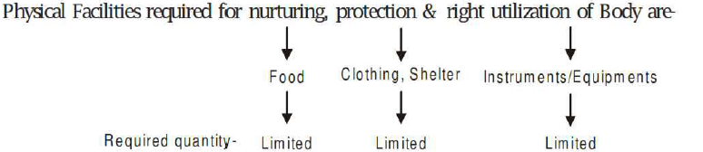

2 MARK QUESTIONS

What is Harmony in self?

Harmony is usually identified as a human value, referring to compatibility and accord in feelings, actions, relationships, opinions, interests, etc. Harmony in the Self is realised when there are no contradictions in the imagination and all imagination is in accordance with natural acceptance.

List out Needs of self and the Needs of body?


Define Will Power and Self Discipline as the aspects of Sanyam.

Sanyama means the feeling of responsibility in the self (I) for nurturing, protection and right utilization of the body. Self control or sanyama is the control of the mind and its desires, urges, emotions and delusions. It is controlling the outgoing tendencies of the mind and the senses and bringing them back to our self within.
Will power is an individuals' activity to harness his or her energy. Energy may be:-
⇒ Physical ⇒ Emotional
⇒ Mental ⇒ Spiritual energy
Self discipline refers to the ability to train our body, mind, emotions and spirit to perform as per a schedule or a routine. Self discipline makes a person strong enough to reject immediate gratification towards a higher goal but it does require efforts and time to become self disciplined.
If a person has will power and is disciplined, he/she gains control over his/her actions. Thus he/she can choose his/her behaviour and reactions, instead of being ruled by them.

What do you mean by Sanyama?
Sanyama means the feeling of responsibility in the self (I) for nurturing, protection and right utilization of the body. Self control or sanyama is the control of the mind and its desires, urges, emotions and delusions. It is controlling the outgoing tendencies of the mind and the senses and bringing them back to our self within.

What do you mean by Swasthya?
Swasthya is the condition of the body where every part of the body is performing its expected function. The word swasthya literally means being anchored to the self, being in close harmony with the self. In other words, swasthya, in Sanskrit means self- dependence (swa = your own).

Discuss Better Relations.
All relationships and connections are very important for character development and success in any aspect of life. Ranging from parents, friends, educational institutions and professional work environments, all of these need human interactions and embodiment of universal human values.
Human relations skills are the capacity to connect with others so that you can constructively collaborate and achieve common goals. This includes being able to understand and empathize with others, as well as being able to communicate effectively. Human relations skills such as communication and handling conflict can help us create better relationships. We can benefit personally and professionally from good human relations skills.

8 Tips for Developing Positive Relationships
- Accept and celebrate differences.
- Listen effectively.
- Give people your time.
- Develop your communication skills.
- Manage mobile technology.
- Learn to give and take feedback.
- Learn to trust more.
- Develop empathy.

